_______ OUR MISSION HOUSE PUBLICATIONS________
Sisters of Mary Immaculate
Books for Religious Education
by Bishop Louis L.R. Morrow, SDB
Excellent in quality, Low in price.

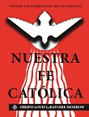
Nuestra Fe Católica (Español) LA PRIMERA EDICIÓN EN ESPAÑOL de "NUESTRA FE CATÓLICA", El libro catequético del obispo Louis L.R. Morrow. Un manual completo de la religión con ilustraciones para dar conocimiento conciso de las enseñanzas y la práctica de la fe católica. La Historia de Salvaciόn. Los Sacramentos. Los Mandamientos y Preceptos de la Iglesia. Un excelente recurso para la catequesis de adultos, el programa RICA y para educadores religiosos. -- $29.50

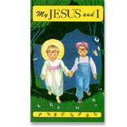
MY JESUS AND I of 40 pictures in full color. a beautiful picture book to inspire young children how to love Jesus as their best friend and to teach prayers with the help of simple text and pictures on each page. The pictures and explanations offer many opportunities for discussion with your little child on so much more than just the prayers introduced. Soft cover 5 x 8 inches - 48 pages. -- $5.00

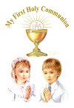
MY FIRST HOLY COMMUNION
Particularly helpful for parents and teachers preparing the little ones for their First Holy Communion. Helps the child to develop a personal love for God. An attractive colorful book that children love to read because they can understand every word of it. 5 in x 7.25 in - 116 pages -- $10.00

ORDER FROM:
OUR MISSION HOUSE
118 Park Road
Leechburg, PA 15656
Phone: 724-845-2828 – E-mail: omhsmi@gmail.com – www.omhsmi.org
Make check payable to: Sisters of Mary Immaculate

Shipping Charges for U.S. - by Media Mail:
$0.01 - $15.00 add $3.50
$15.01 - $25.00 add $4.50
$25.01 - $40.00 add $5.50
$40.01 - $55.00 add $6.50
$55.01 - $75.00 add $7.50
Above $75.00 add $1.00 for each additional $10.00
The proceeds from your purchase benefit our missions in India and Africa.
Thank you and God bless you.

